Android Payload Creation
Student Name: Mahrukh
Environment: Controlled & Isolated Lab Setup

1. Network Setup (Bridged Adapter)
Kali Linux was configured with a Bridged network to communicate with the Android device. This allowed both devices to be on the same local network.
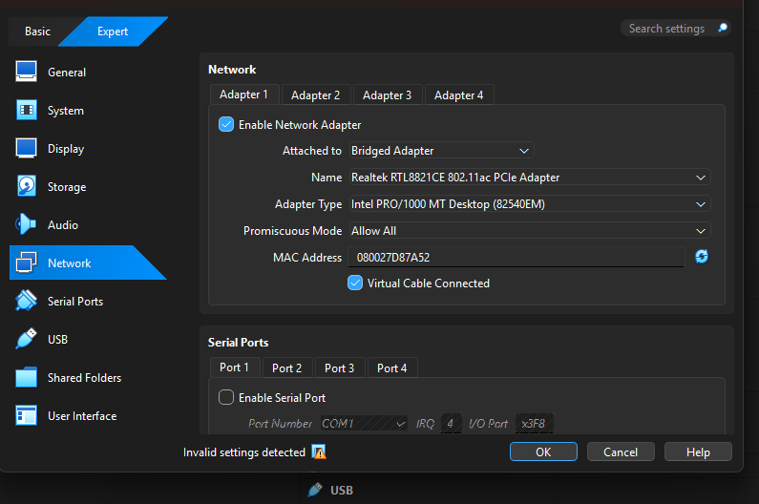

2. Android Device Configuration
A physical Samsung Android phone was used for this task. The device was running Android version 15.
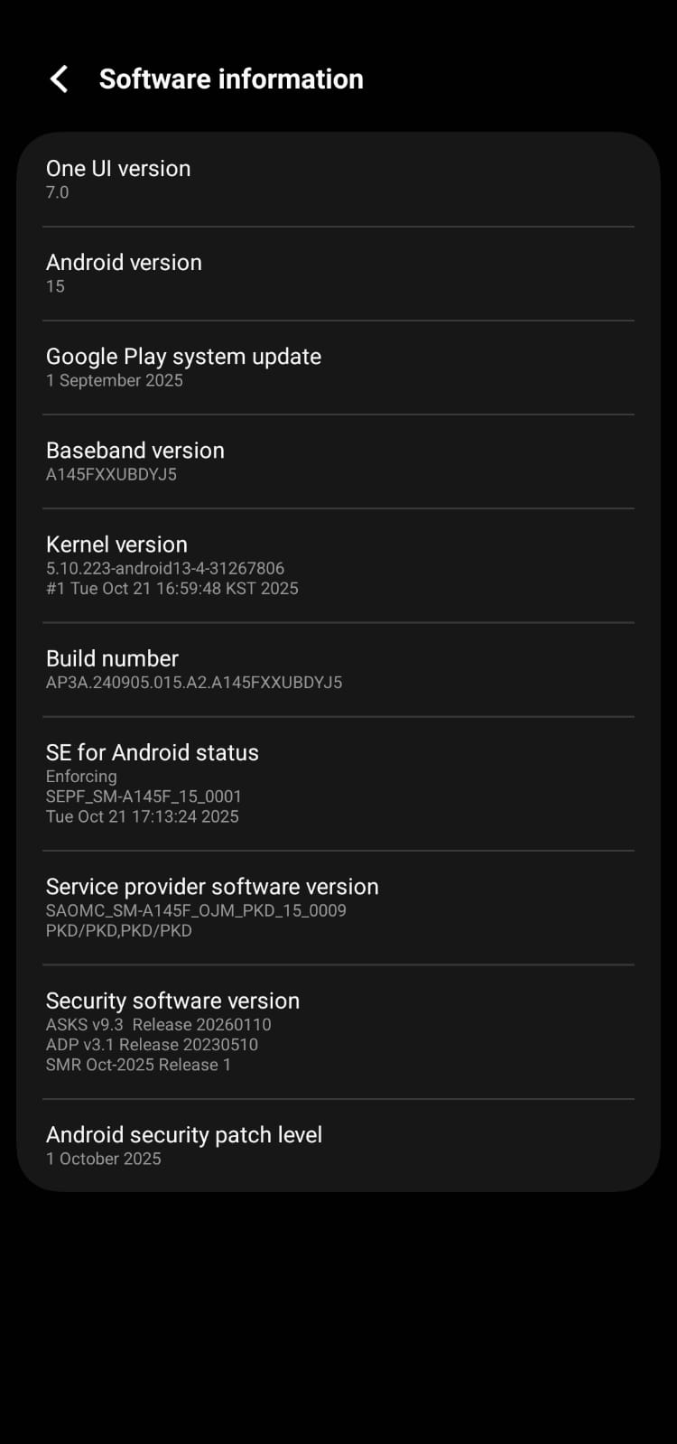

3. Termux Installation on Android
Termux was installed on the Android device using F-Droid. This provided a Linux-like environment to run Python scripts.
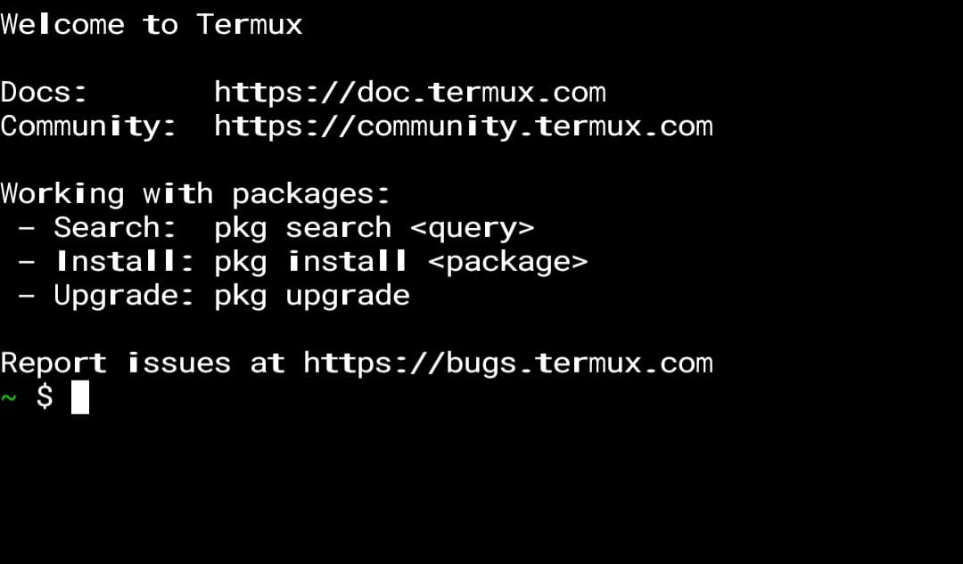

4. IP Address Verification
IP addresses of Kali Linux were checked and then connectivity was tested between the Android device and Kali Linux. Successful communication confirmed correct network setup.

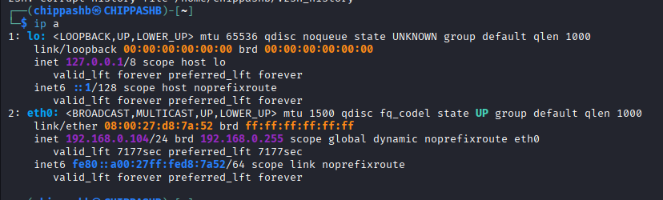
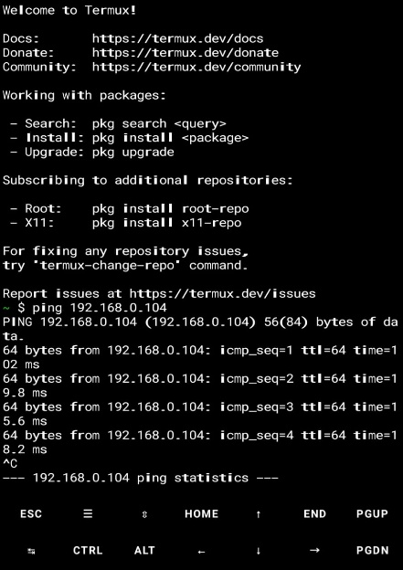

5. Python Reverse Shell Script Execution on Android
The Python reverse shell script was executed inside Termux. The script initiated a connection to Kali Linux.
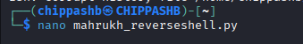

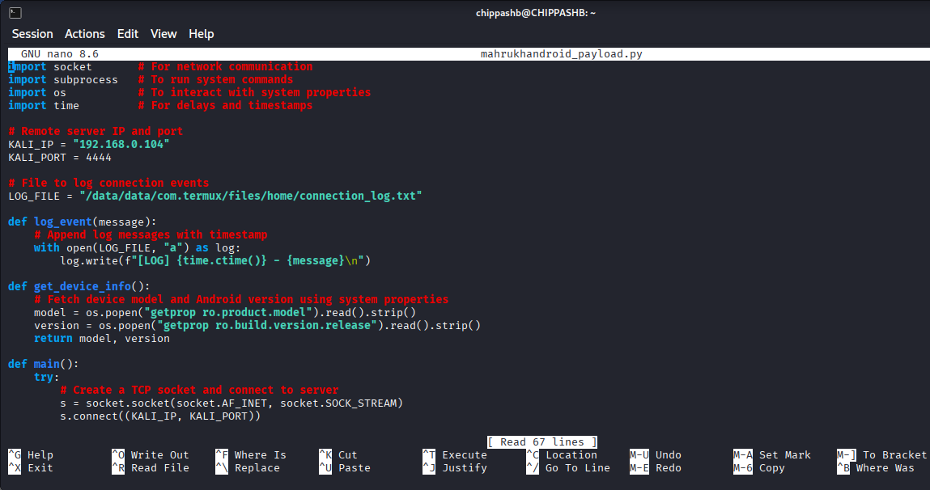
File is transferred to termux in phone
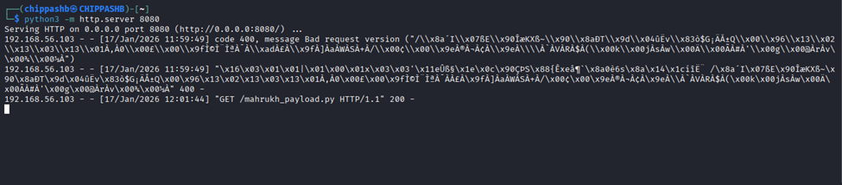
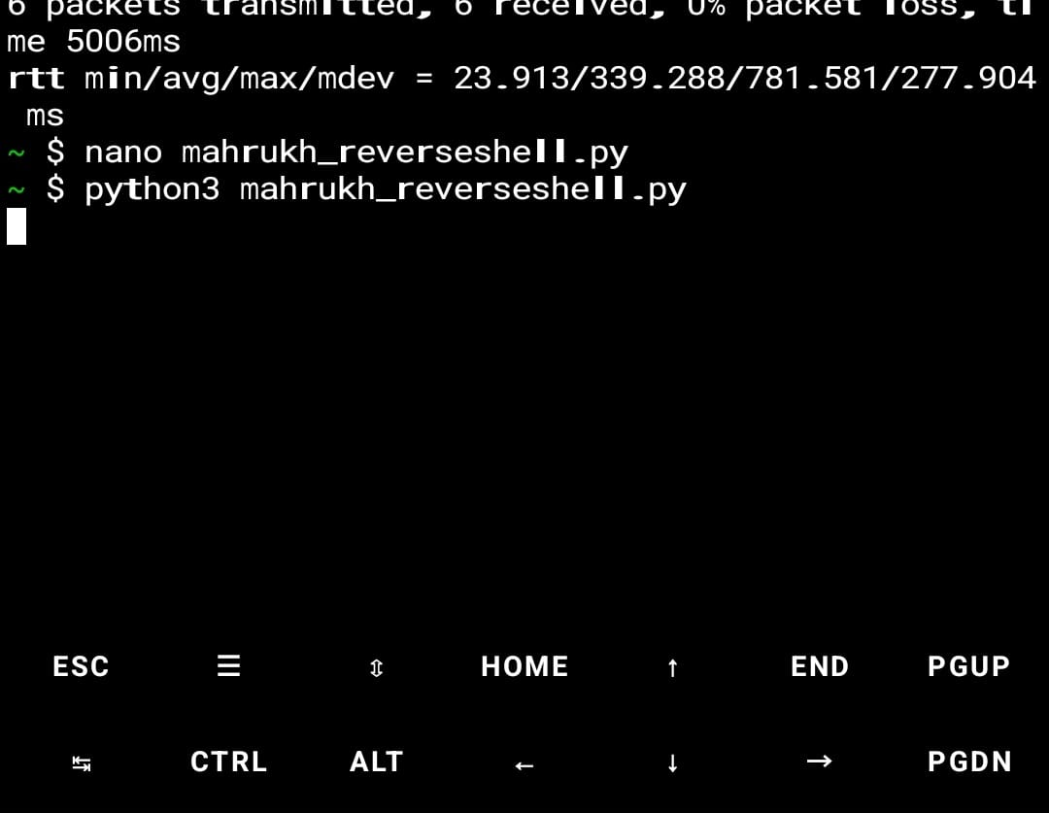

6. Listener Setup on Kali Linux (Netcat)
A Netcat listener was started on Kali Linux using port 4444. Kali waited for the incoming Android connection.
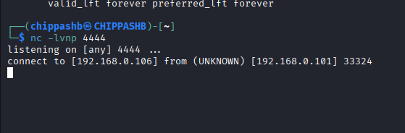

8. Python Code Execution
A reverse shell session was successfully executed after netcat was setted up for listening.


9. Reverse Shell Session Establishment
A reverse shell session was successfully established from the Android device to Kali Linux. Remote interaction was confirmed.

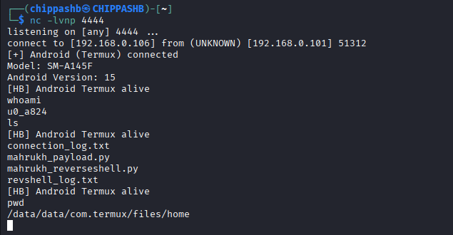

10. Wireshark Traffic Analysis (Port 4444)
Wireshark was running on Kali Linux during the session. Network traffic on port 4444 was captured and analyzed.
